**AIM**

Model a simple HTML file describing your hometown (demonstrate the use of different tags).

**Program Code**

<html>

<head>

<title>Hometown</title>

</head>

<body bgcolor="black" background="https://i.pinimg.com/originals/84/5f/91/845f91e270e7d008f22a0742870cb42a.png">

<h2 align="center"><font color="red"><i><b>THRISSUR</font></i></b></h2>

<p><font color="black"><i>Thrissur, formerly Trichur, also known by its historical name Thrissivaperur, is a city and the headquarters of the Thrissur district in Kerala, India. It is the third largest urban agglomeration in Kerala after Kochi and Kozhikode, and the 21st largest in India.The city is built around a 65-acre (26 ha) hillock called the <b><font color="red">Thekkinkaadu Maidaanam</font></b> which seats a large Hindu Shiva Temple. It is located central of the state</i></p>

<p><font color="black"><i>Thrissur is also known as the <font color="red">Cultural Capital of Kerala </font>because of its cultural, spiritual and religious leanings throughout history.The city centre contains the <font color="red">Kerala Sangeetha Nadaka Academy</font>, Kerala Lalithakala Akademi and Kerala Sahitya Academy. The city hosts the<font color="red"> Thrissur Pooram festival</font>, the most colourful and spectacular temple festival in Kerala. The festival is held at the Thekkinkadu Maidan in April or May, in the Malayalam month 'medam'.The city is also a big centre for silks and gold jewellery. Thrissur attracts the largest number of domestic tourists in Kerala.</font></i></p>

<ul><font color="red">Top Attractions</font>

<li>Athirappilly waterfall</li>

<li>Vadakkunathan Temple</li>

<li>Snehatheeram Beach</li>

<li>Guruvayoor Temple</li>

</ul>

</font>

</body>

</html>

**Output**

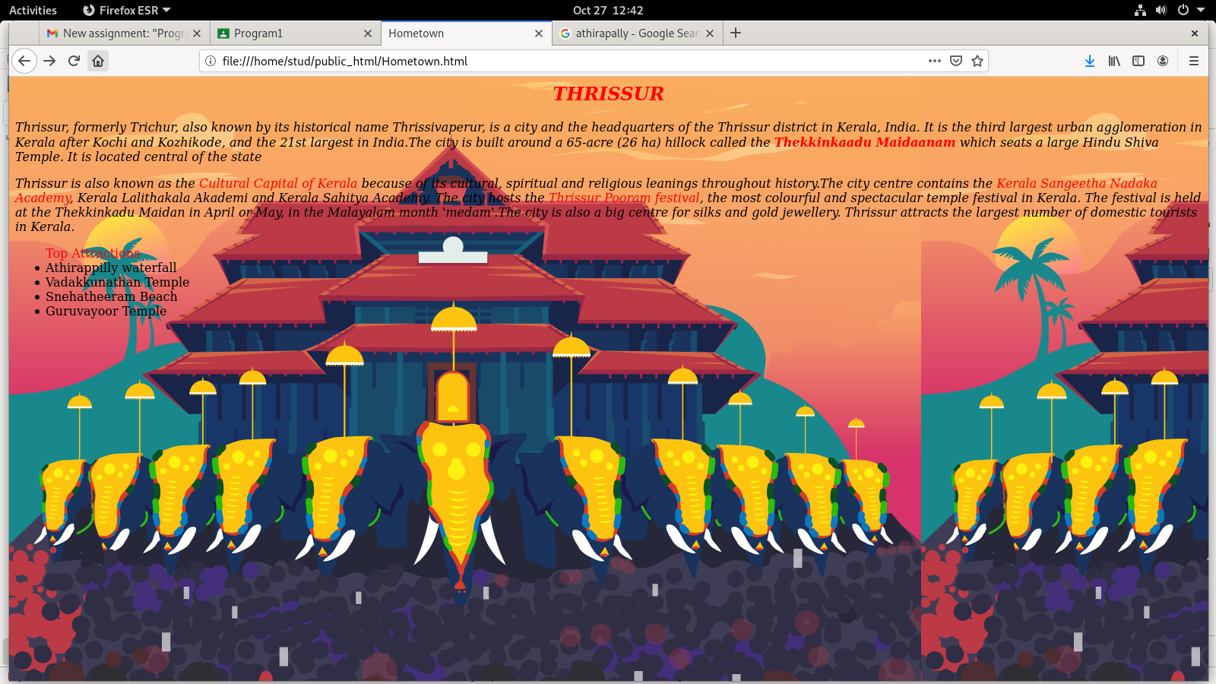

**AIM**

Create a webpage for displaying your biodata which contains images, tables, and also link within a page

**Program Code**

first page:

<html>

<head>

<title>Biodata</title>

</head>

<body bgcolor="black">

<h3 align="center"><i><font color="red">BIODATA-AARATHI SURESH</i></h2></font>

<img src="https://images.unsplash.com/photo-1562690868-60bbe7293e94?ixlib=rb-4.0.3&ixid=MnwxMjA3fDB8MHxzZWFyY2h8Mnx8cm9zZSUyMGZsb3dlcnxlbnwwfHwwfHw%3D&auto=format&fit=crop&w=500&q=60" width=230 height=200 align="right">

<ul>

<li><a href="/home/stud/public_html/personaldata.hml"><font color="red">PersonalData</font></a></li>

<li><a href="C:\Users\User\Documents"><font color="red">Academics</font></a></li>

</ul>

</body>

</html>

second page:

<html>

<head>

<title> personaldata</title>

</head>

<body bgcolor="black">

<h2 align="center"><font color="green"<b><i>PersonalData</i></font></b></h2>

<p>

<ul>

<li><font color="white">AARATHI SURESH</li>

<li>Gender:Female</li>

<li>Father's Name:N.Suresh</li>

<li>Mother's Name:Sylaja Suresh</li>

<li>DOB:09/03/2000</li>

<li>Adress:"Geethanjali",Aarukkulangara temple road,Ollur,Thaikkattussery(p.o),Thrissur</li>

</font>

</ul>

</p>

</body>

</html>

Third page:

<html>

<head><title>academics</title></head>

<body bgcolor="gray">

<h2 align="center"><i><font color="green">Academics</i></h2>

<table border="2" align="center"><font color="white">

<tr>

<th>course</th>

<th>Name of institution</th>

<th>University/Board</th>

<th>percentage of marks</th>

</tr>

<tr>

<td>SSLC</td>

<td>DEEPTHI HS THALORE</td>

<td>Board of publicexamination kerala</td>

<td>89%</td>

</tr>

<tr>

<td>plus 2</td>

<td>DEEPTHI HSS THALORE</td>

<td>Board of higher secondary examination Kerala</td>

<td>65%</td>

</tr>

<tr>

<td>Bsc CS</td>

<td>Donbosco college mannuthy</td>

<td>CALICUT UNIVERSITY</td>

<td>55%</td>

</tr></font>

</table>

</body>

</html>

**Output**

**First.html**

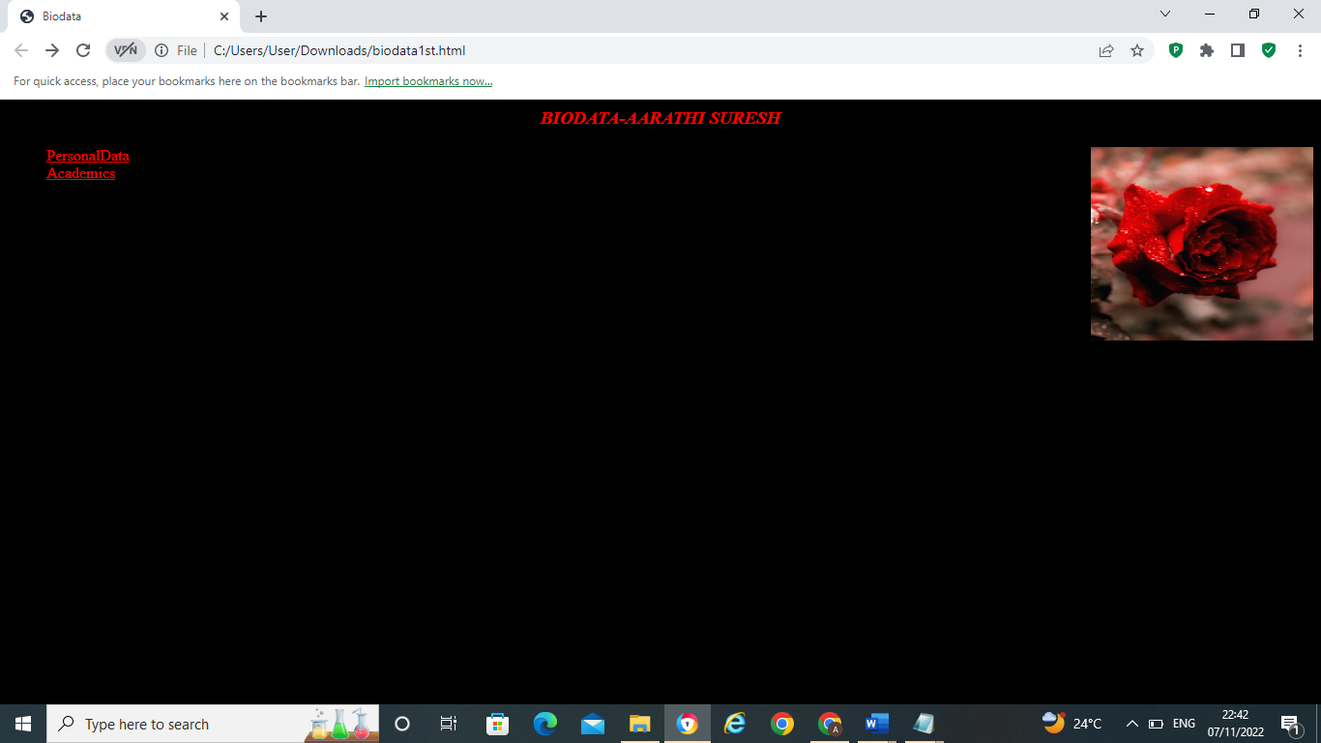

secondpage.html

Thirdpage.html

**AIM**

Design an application form for MCA course in FISAT using HTML.

**Program Code**

<html>

<head>

<title>form</title>

</head>

<body>

<h1 align="center" bgcolor="white"><font color="black"><i>FEDERAL INSTITUTION OF SCIENCE AND TECHNOLOGY</i></font></h1>

<h2 align="center"><font color="black">MCA-APPLICATION FORM</h2>

<form>

Name:&nbsp&nbsp&nbsp&nbsp&nbsp&nbsp&nbsp&nbsp&nbsp&nbsp<input type="text"><br><br>

DOB:&nbsp&nbsp&nbsp&nbsp&nbsp&nbsp&nbsp&nbsp <input type="date" id=”DOB” name=”DOB”><br><br>

Father's Name:&nbsp&nbsp<input type="text"><br><br>

mother's name:&nbsp<input type="text"><br><br>

Address:&nbsp&nbsp&nbsp&nbsp<textarea name="address" cols="40" rows="5"></textarea><br><br>

MOB:&nbsp&nbsp&nbsp<input type=”number” id=”Mob” name=”Mob”min=”1” max=”10”><br><br>

Email-id:&nbsp&nbsp&nbsp<input type=”email” id=”email” name=”email”><br><br>

Gender:&nbsp&nbsp<input type="radio" name="gender" value="male">MALE

<input type="radio" name="gender" value="female">FEMALE<br><br>

Qualification:&nbsp<select id="Qualification" name="qualification">

<option value="BCA">BCA</option>

<option value="Bs CS">Bsc.CS</option>

<option value="BA">BA</option>

<option value="Bcom">Bcom</option>

<option value="Bsc Maths">Bsc Maths </option>

<option value="Bsc IT">Bsc IT </option>

</select>

<br><br>

Degree Percentage:<input type=”number” id=”percentage” name=”percentage”>

<input type=”checkbox” id=”check” name=”check” value=”Whether candidate has studied mathematics at +2/degree”><br><br><br>

<input type=button value=submit>

<input type=button value=reset>

</form>

</body>

</html>

**Output**

**AIM**

Create a HTML page with different types of frames such as floating frame, navigation frame & mixed frame.

**Program Code**

1.Main.html

<html>

<head><title>main</title>

</head>

<body bgcolor="white">

<h1 align="center"><font color="blue"><i>FRAMES</i></font></h1>

<h3><i><a href="frames.html" target="frame" color="red">Frame tags</a></i></h3>

<h3><i><a href="frame2.html" target="frame">Frame tags-part2</a></i></h3>

<iframe src="C:\Users\User\Downloads\frames.html" name="frame" width=500 height=400 > </iframe>

</html>

</body>

</html>

2.Frames.html

<html>

<head><title>Frames</title></head>

<frameset rows="50%,*">

<frame src="1stpage.html">1st Frame

<frame src="secondpage.html">second Frame

</frameset>

</html>

3.Frame2.html

<html>

<head><title>Frames</title></head>

<frameset rows="50%,*">

<frame src="third.html">

<frame src="fourth.html">

</frameset>

</html>

4.1stpage.html

<html>

<head><title>1st page</title></head>

<body>

<h1 align="center"><font color="blue"><i>Frames tag</i></h1>

<p>

<ul>

<li>src</li>

<li>name</li>

<li>frameborder</li>

</ul>

</p>

</body>

</html>

5.Secondpage.html

<html>

<head><title>Second page</title></head>

<body>

<p><i>

<font color="red">src:</font> is implemented for fetching the HTML file that needs to be loaded in one of the frames. It takes the value as filename.html or filename.htm within double-quotes. <br>

<font color="red">name: </font>facilitates you in giving a name to your frame, and hence you can indicate which frame(s) you are supposed to load into your page.<br>

<font color="red">frameborder: </font>is used for specifying if the borders are being shown in the frame you are using, and you can assign values either: 1 (yes) or 0 (no) for it.</i>

</p>

</body>

</html>

6.Third.html

<html>

<head><title>1st page</title></head>

<body>

<h1 align="center"><font color="red"><i>Frames tag-part2</i></h1>

<p>

<ul>

<li>marginwidth</li>

<li>marginheight</li>

<li>scrolling</li>

</ul>

</p>

</body>

</html>

7.Fourth.html

<html>

<head><title>Second page</title></head>

<body>

<p><i>

<font color="red">marginwidth:</font> facilitates specifying the frame borders width spacing on the left and right sides. It takes the value in pixels. <br>

<font color="red">marginheight:</font> facilitates specifying the frame borders height spacing on top and bottom sides. It also takes the value in pixels.<br>

<font color="red">scrolling:</font> is used for activating and deactivating the scroll-bar appearance in your frame and takes either yes, no, or auto as values to be assigned to it within double-quotes.</i>

</p>

</body>

</html>

**Output**

Main .html

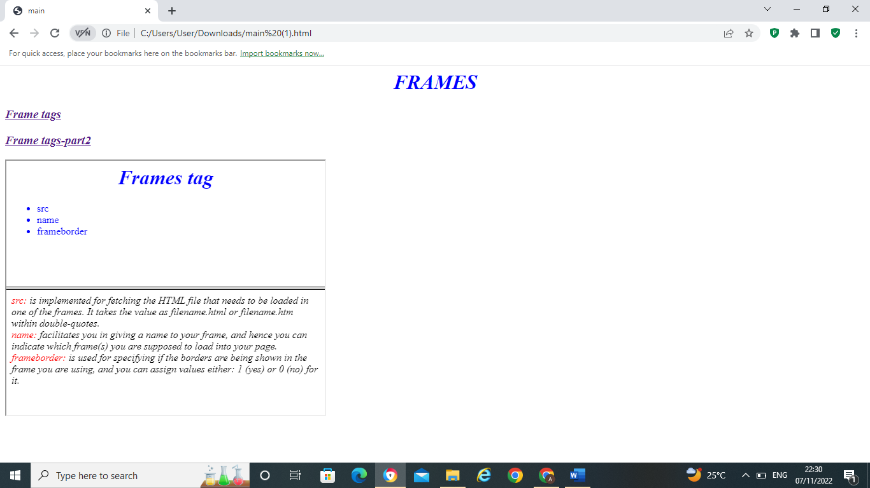

**AIM**

Analyze CSS by applying the different styles using inline, external & internal style sheets in a HTML file.

**Program Code**

Main.html

<html>

<head><title>CSS</title></head>

<body bgcolor="gray"><font color="black">

<h1 align="center"><font color="green"><i>CSS</i></font></h1>

<p><i>

CSS is the language for <b style="color:red;font-family:arial;">describing the presentation of Web pages, including colors, layout, and fonts</b>. It allows one to adapt the presentation to different types of devices, such as large screens, small screens, or printers.

CSS is independent of HTML and can be used with any XML-based markup language.

</i></p>

<ul>

<a href="inline.html" style="color:"blue;">Inline css</a><br>

<a href="internal.html"style="color:"blue;">Internal css</a><br>

<a href="external.html"style="color:"blue;">External css</a><br>

</ul>

</font>

</body>

</html>

Inline.html

<html>

<head><title>INLINECSS</title></head>

<body bgcolor="Black "style="color:yellow;">

<h1 align="center" style="color:red;"><i>INLINECSS</i></h1>

<p style="font-family:arial;"><i>

Inline CSS allows you to apply style rules to specific HTML elements.

<b style="color:red;">Inlining CSS means putting CSS into an HTML file instead of an external CSS</b>.

Since inline CSS allows the application of a unique style to one HTML element,

its usage is limited but is beneficial for creating unique attributes.</p>

<ul >

<a href="css.html" style="color:blue;font-size:20px;">Homepage</a><br>

</ul>

</body>

</html>

internal.html

<html>

<head><title>INTERNALCSS</title>

<style>

body{

color:yellow;

}

h1{

color:red;

}

p{

font-family:arial;

}

b{

color:red;

}

ul{

color:blue;

font-size:20px;

}

</style>

</head>

<body bgcolor="black">

<h1 align="center"><i>INTERNAL CSS</i></h1>

<p ><i>

An internal CSS is used to define a style for a single HTML page.

<b> An internal CSS is defined in the <head> section of an HTML page, within a element.</b>

Since you'll only add the code within the same HTML file, you don't need to upload multiple files.

</p>

<ul >

<a href="css.html">Homepage</a><br>

<a href="inline.html">Inline css</a><br>

</ul>

</body>

</html>

Style.css

body {

           background-color: Plum;

         }

h1 {

       color: MediumPurple;

     }

h3 {

        color: Indigo;

      }

p {

      color: DarkViolet;

    }

externl.html

<html>

<head><title>externalcss</title>

<link rel="styesheet" type=text/css href="externalcss.css">

</head>

<body bgcolor="Black>

<h1 align="center"><i>EXTERNAL CSS</i></h1>

<p><i>

An external style sheet is a separate<b> CSS file that can be accessed by creating a link within the head section of the webpage.</b> Multiple webpages can use the same link to access the stylesheet.

The link to an external style sheet is placed within the head section of the page.

</p>

<ul >

<a href="css.html" >Homepage</a><br>

</ul>

</body>

</html>

Csspage;

body{

color:yellow;

}

h1{

color:red;

}

p{

font-family:arial;

}

b{

color:red;

}

ul{

color:blue;

font-size:20px;

}

**Output**

Main.html

Inline.html

Internal.html

External.html

**AIM**

Create a HTML registration form and to validate the form using JavaScript code.

**Program Code**

<html>

<head>

<title>JS</title>

<script style"color:red;">

function validateForm()

{

var x=document.forms["form1"]["name1"].value;

if(x==""){

alert("name must be filled out");

return false;

}

var y=document.forms["form1"]["address"].value;

if(y==""){

alert("Address must be filled out");

return false;

}

var z=document.forms["form1"]["email1"].value;

if(z==""){

alert("Email-id must be filled out");

return false;

}

var n=document.forms["form1"]["Mobnum"].value;

if(isNaN(n)){

document.getElementById("mob").innerHTML="please enter Numeric value";

return false;

}

}

</script>

</head>

<body>

<hr>

<h1 align="center" bgcolor="white"><font color="black">FORM</i></font></h1>

<form name="form1" action="jssub.html" onsubmit="return validateForm()"method="post">

Name:&nbsp&nbsp&nbsp&nbsp&nbsp&nbsp&nbsp <input type="text" name="name1"><br><br>

DOB:&nbsp&nbsp&nbsp&nbsp&nbsp <input type="date" id=”DOB” name=”DOB”><br><br>

Father's Name:&nbsp&nbsp<input type="text"required><br><br>

mother's name:&nbsp<input type="text"required><br><br>

Address:&nbsp&nbsp <textarea name="address" cols="40" rows="5" ></textarea><br><br>

MOB:&nbsp&nbsp&nbsp<input type="text" name="Mobnum">

<span id="mob"></span><br><br>

Email-id:&nbsp&nbsp&nbsp<input type="email" id="email" name="email1"><br><br>

Gender:&nbsp&nbsp<input type="radio" name="gender" value="male">MALE

<input type="radio" name="gender" value="female">FEMALE<br><br>

<input type="submit" value="submit" >

<input type="reset" value="reset"><hr>

</form>

</body>

</html>

**Output**

**Name validation:**

Address validation:

Number validation

**AIM**

Create a HTML page to explain the use of various predefined functions in a string and math object in java script.

**Program Code**

<html>

<head></head>

<body>

<h1 align="center" style="color:blue;">Javascript String Functions</h2>

<h2>Length of a string</h2>

<p>The length of the string is:</p>

<p id="demo"></p>

<h2>The slice() Method</h2>

<p>The sliced part of the string is:</p>

<p id="slice"></p>

<h2>Substring()</h2>

<p>The substring() method extract a part of a string and returns the extracted parts in a new string:</p>

<p id="substrng"></p>

<h2>Replace()</h2>

<p>Replace "Morning" with "Evening" in the paragraph below:</p>

<button onclick="myFunction()">Try it</button>

<p id="repl">Good Morning!</p>

<h2>concat()</h2>

<p>The concat() method joins two or more strings:</p>

<p id="con"></p>

<h2>The trim() Method</h2>

<p id="trim1"></p>

<h2> split()</h2>

<p id="splt"></p>

<h1 align="center" style="color:red">Javascript Math Functions</h1>

<h2> Math.round()</h2>

<p>Math.round(x) returns the value of x rounded to its nearest integer:</p>

<p id="round"></p>

<h2> Math.ceil()</h2>

<p>Math.ceil() rounds a number up to its nearest integer:</p>

<p id="ceil"></p>

<h2> Math.floor()</h2>

<p>Math.floor(x) returns the value of x rounded down to its nearest integer:</p>

<p id="floor"></p>

<h2>Math.trunc()</h2>

<p>Math.trunc(x) returns the integer part of x:</p>

<p id="trunc"></p>

<h2>Math.sign()</h2>

<p>Math.sign(x) returns if x is negative, null or positive:</p>

<p id="sign"></p>

<h2> Math.pow()</h2>

<p>Math.pow(x,y) returns the value of x to the power of y:</p>

<p id="pow"></p>

<h2> Math.sqrt()</h2>

<p>Math.sqrt(x) returns the square root of x:</p>

<p id="sqrt"></p>

<h2>Math.log()</h2>

<p>Math.log() returns the natural logarithm of a number:</p>

<p id="log"></p>

<script>

let text = "ABCDEFGHIJKLMNOPQRSTUVWXYZ";

document.getElementById("demo").innerHTML = text.length;

let a = "Apple, Banana, Kiwi";

let part = a.slice(7,13);

document.getElementById("slice").innerHTML = part;

let str = "Apple, Banana, Kiwi";

document.getElementById("substrng").innerHTML = str.substring(7,13);

function myFunction() {

let r = document.getElementById("repl").innerHTML;

document.getElementById("repl").innerHTML =r.replace("Morning","Evening");

}

let x = "Hello";

let y = "World!";

let z = x.concat(" ",y);

document.getElementById("con").innerHTML = z;

let text1 = " Hello World! ";

let text2 = text1.trim();

document.getElementById("trim1").innerHTML =

"Length text1 = " + text1.length + "<br>Length text2 = " + text2.length;

let k = "Hello";

const Arr = k.split("");

k = "";

for (let i = 0; i < Arr.length; i++) {

k += Arr[i] + "<br>"

}

document.getElementById("splt").innerHTML = k;

document.getElementById("round").innerHTML = Math.round(5.7);

document.getElementById("ceil").innerHTML = Math.ceil(3.2);

document.getElementById("floor").innerHTML = Math.floor(3.7);

document.getElementById("trunc").innerHTML = Math.trunc(7.8);

document.getElementById("sign").innerHTML = Math.sign(10);

document.getElementById("pow").innerHTML = Math.pow(3,3);

document.getElementById("sqrt").innerHTML = Math.sqrt(64);

document.getElementById("log").innerHTML = Math.log(1);

</script>

</body>

</html>

**Output**

**AIM**

Create a HTML page to change the background color for every click of a button using JavaScript Event Handling.

**Program Code**

<html>

<head>

<title> bgcolor </title>

</head>

<body style = "text-align:center;">

<h1 style = "color:red;" >

Welcome

</h1>

<button type="button" id="color-button" onclick="changeBg()">Click Here

</button>

<br>

<script>

document.writeln( "Click on button to change the background color");

const pageBody = document.querySelector("body");

function changeBg()

{

let color = '#'+(Math.random()*0xFFFFFF<<0).toString(16);

pageBody.style.background = color;

}

</script>

</body>

</html>

**Output**

